***Data Base Foundations***

**

*Carlos Andrés Sierra*

***Juan Daniel Vanegas Mayorquin***

***(20222020077)***

***Systems Engineering***

***DB design - Workshop #1***

***March 16th Bogotá D.C 2024***

**YouTube relational data base modeling**

**Step #0 – Define Components**

Lets start thinking about what an user and a creator can do into de app, first thing first, we gotta take the main objective in de app and think the whole model around it.

YouTube is a web platform to share content in video format. The app is made of users and creators, creators made videos, users watch it.

1. **User stories that can support my design**
   1. An user can watch a video, like to it, dislike to it, comment about it, share it and make a playlist with the video
   2. An user can subscribe to a creator’s channel and get notifications from it.
   3. An user can upload, modify descriptions, delete videos and visualize their stats
   4. An user can make live streaming and save it like a type of video into his channel
   5. An user’s video can be categorized by the video’s type of content.

**Step #1 – Define Entities**

E.1 Users

E.2 Videos

E.3 Channel

E.4 Subscription

E.5 Notifications

E.6 Playlists

E.7 LiveStreaming

E.8 Interaction

E.9 Categories

E.10 Trends

**Step #2 – Define attributes per entity**

E.1 Users = {id, name, googleEmail, profilePic, country. signupDate, url}

E.2 Video = {id, title, description, thumbnail, length, uploadDate, category, views, like, dislikes, comments, channelId, url}

E.3 Channel = {id, name, description, profilePic, banner, signupDate, subsAmount, videosAmount, totalViews, category, url}

E.4 Subscription = {id, userId, chanelId, subscriptionDate}

E.5 Notifications = {id, userId, chanelId, videoId, notificationDate, url}

E.6 Playlist = {id, name, description, creationDate, videoAmount, privacityState, userId, videoId, url}

E.7 LiveStreaming = {id, title, description, thumbnail, length, liveDate, category, viewers, likes, dislikes, chat, channelId, url}

E.8 Interaction (Like/Dislike/Comment) = {id, typeInteraction, description, userId, videoId}

E.9 Categories = {id, name, description, videoId, chanelId, url}

E.10 Trends = {id, name, videoId, url}

**Step #3 – Define Relationships**

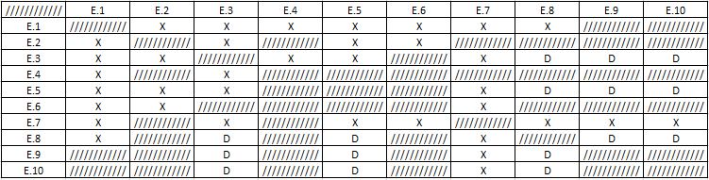

**Step #4 – Define relationships types**

E.1 many to many E.2

E.1 one to one E.3

E.1. many to one E.4

E.1 many to many E.5

E.1 many to one E.6

E.1 one to one E.7

E.1 can be one to one E.8 (o one to many con comment)

E.2 one to many E.3

E.2 one to one E.5

E.2 many to many E.6

E.2 many to many E.8

E.2 one to one E.9

E.2 one to one E.10

E.3 one to many E.4

E.3 one to many E.5

E.3 one to many E.7